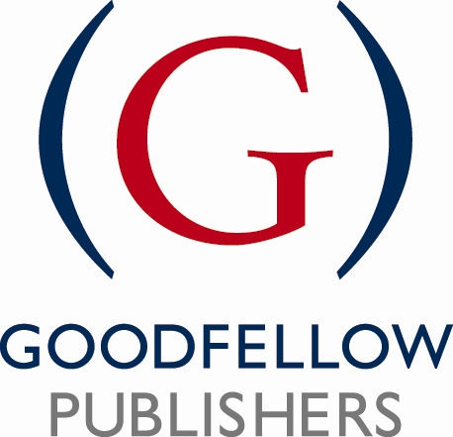

Proposal Form

Please complete the questions below including as much detail as possible. This document will be used to give us an initial indication of the project, its outline and it’s potential. Please be aware that this is the document likely to be sent out for double blind review, so bear in mind that it needs to include all important information that reviewers would need to consider.

Many thanks for sending us your proposal.

Type into the right hand column, which will expand as you type where necessary.

Date:
SUGGESTED TITLE
AND SUB TITLE
AUTHOR(S) AND/OR EDITORS
DETAILS
Include email and postal addresses and telephone contact details (in the event of sending this document out for review, we will remove this detail).

Where possible, please also attach a brief CV, including relevant career details, present appointment, and a full list of previous publications and anything due for publication. You may wish to send this as a separate attachment.
DESCRIBE THE INTENDED MARKET(S)/AUDIENCE
- Define as accurately as possible the target audience. Indicate primary and secondary markets, and for a practitioner audience please list the relevant job titles/functions.
- If it has academic appeal, where possible list the qualifications for which the book will be recommended reading. Include typical course titles and levels of study.
- Will it have an international appeal?

PROPOSED CONTENTS
Supply a list of chapters with as much detail as possible, explaining briefly what each chapter will cover. You may put this on a separate sheet, or keep in this document.
Do you have draft/sample chapters you can send alongside the proposal?

SIZE OF BOOK & SCHEDULE
Please indicate the proposed number of words, and the approx number of diagrams.

PROPOSED DELIVERY OF FINAL MANUSCRIPT
Please try to be as realistic as possible. Is the published work time sensitive?

SUPPLEMENTS
Detail any supplementary material that you intend to provide for readers (case studies, companion websites).

COMPETITION
List the main competing titles, (list author, title, edition, publisher, publication date, price, page count) and products and detail their major strengths and weaknesses. You should list the advantages your proposal will have over each competing title.
If you believe there are no competing works, where do people currently go to find out about this subject?

MARKET BENEFITS
What do you consider the unique selling points of your proposal. Why would people buy it? Think in terms of the back cover of the book…if you were in a bookshop reading the back cover, what would make you buy it. It may be helpful to list these as bullet points or write as a combination of text and points.

FEATURES & BENEFITS
List five (or more) major or specific features of your proposal and the best specific examples therein. Please list in order of importance.
ADDITIONAL INFORMATION
Please add any other information that you think might be helpful to us in evaluating your proposal.

Please email your completed proposal as an attachment to:

Sally North, Publisher
Goodfellow Publishers Limited
Mobile: 07748 635 789
>Email: sally.north@goodfellowpublishers.com
Goodfellow Publishers Limited
6 Nourse Close Woodeaton Oxford
OX3 9TJ Registered Company No. 06517764

